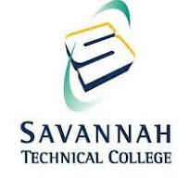

Savannah Technical College
Biennial Review of Compliance with the
Drug-Free Schools and Communities Act
August 2022 to July 2024

Submitted by
Dr. Terry Brasier
Vice President for Student Services
Approved

Final Approval: March 2025

TABLE OF CONTENTS
- Introduction/Overview 3
- Annual Policy Notification Process 4
- Program Description 7
- Program Results and Goal Achievement 8
- Program Strengths and Areas of Concerns 9
- Program and Policy Revision Recommendations 10
- College Related Policies and Publications
Drug and Alcohol Abuse Prevention Program (DAAPP)
Drug and Alcohol Policy and Procedure
Code of Student Conduct
Student Disciplinary Procedure
New Employee Orientation Handouts
Student Brochures and Pamphlets

Introduction/Overview

The Drug Free Schools and Campuses Regulations (34 CFR Part 86) of the Drug-Free Schools and Communities Act (DFSCA) require an institution of higher education (IHE) such as Savannah Technical College (STC) to certify it has implemented programs to increase awareness and prevention of alcohol and other drug abuse. Additionally, DFSCA insures that IHE’s implement programs and procedures preventing the distribution of illicit drugs both by STC students and employees both on its premises and as a part of any of its activities. At a minimum, each institution of higher education must annually distribute the following in writing to all students and employees:

  - Standards of conduct that clearly prohibit the unlawful possession, use or distribution of illicit drugs and alcohol by students and employees;
  - A description of the legal sanctions under local, state, or federal law for the unlawful possession or distribution of illicit drugs and alcohol;
  - A description of any drug or alcohol counseling, treatment, or rehabilitation or reentry programs that are available to students and employees; and
  - A clear statement that the institution will impose sanctions on students and employees and a description of those sanctions, up to and including expulsion or termination of employment and referral for prosecution, for violations of the standards of conduct.

The law further requires that the institution conduct a biennial review of its program with the following objectives:

  - Determining the effectiveness of the Drug and Alcohol Abuse Prevention Program (DAAPP) and implementing changes to the alcohol and other drug programs if they are needed; and
  - To ensure that the sanctions developed are enforced consistently.

The biennial review must also include a determination as to:

  - The number of drug and alcohol related violations and fatalities occurring on the campus or as part of their activities that are reported to campus officials;
  - The number and types of sanctions the IHEs impose on students or employees as a result of such violations or fatalities.

STC acknowledges its legal obligation to conduct a biennial review of compliance with the Drug- Free Schools and Communities Act (DFSCA) and authorizes an administrative review to be conducted to determine if the college fulfills the requirements of the previously mentioned Federal regulations. The Vice President for Student Affairs office is responsible for conducting the review and reporting on the findings. The purpose of this report is to comply with the DFSCA by using data collected over the past two years and to provide evidence of the procedures in place for subsequent biennial reports. The following campus units provide information and data for biennial reports:

    - Office of the Vice President for Student Affairs
    - Office of Human Resources
    - Office of STC Police

Specifically, the following individuals provided information and helped compile and assess data for this Biennial Review:

    - Office of the Vice President of Student Affairs, Dr. Terry Brasier, Vice President of Student Affairs and Teresa Berry, Administrative Assistant
    - Office of Human Resources, Jasmine Sanders, Executive Director of Human Resources and Organizational Development
    - Office of STC Police, Wayne Willcox, Chief of Campus Police
    - Office of Institutional Effectiveness, Kelley Riffe, Institutional Effectiveness/Grant Director
    - Department of Student Support Services
      - Dean of Student Advising and Support Services, Terrie Sellers
      - Special Population’s Coordinator, Ailerua Crawford
      - Student Navigator, Wendi Gowans

The intention of this document is to meet the legal requirements of conducting a biennial review and also summarize the programs and activities related to alcohol and drug prevention on STC’s campus during the 2022-23 and 2023-2024 academic years. The following information was examined for the biennial review:

    - Drug and Alcohol Policy
    - Alcohol and drug information provided to students
    - College policies for students and employees related to drug and alcohol use and the sanctions imposed for failure to comply
    - Drug and Alcohol Abuse Prevention Program
    - Various resources available to students and employees regarding drug and alcohol abuse
    - Incident reports filed by the STC Police Department during the 2022-2023 and 2023- 2024 academic years related to any possible infractions of the drug and alcohol policy presented to students
    - Code of Student Conduct files related to any possible infractions of the Drug and Alcohol policy presented to students

The Biennial Review report will be filed both electronically and hard copy. The electronic file will be located on our Consumer Information page located at https://www.savannahtech.edu/about-savannah-technical-college/student-consumer-information/ under Health & Safety. The hard copy will be located in the Office of the Vice President for Student Affairs.

Annual Policy Notification Process

STC is committed to providing a drug free environment for all students and staff. STC strives to remain in compliance with the requirements of the Drug-Free Schools and Communities Act. The College has adopted and implemented programs to prevent the abuse of alcohol and use or distribution of illicit drugs both by students and employees (both on its premises and as a part of any of the college’s activities).
Additionally, the Offices of Human Resources and Student Affairs send out the following notices to all employees and students annually.

Sent on February 24, 2024

Dear STC students, faculty and staff:
The Drug-Free Schools and Campuses Regulations [Edgar Part 86] of the Drug-Free Schools and Communities Act of 1989 requires that institutions of higher education provide students and employees with a copy of the written policies and laws related to drugs and alcohol. Savannah Technical College clearly prohibits the unlawful possession, use, or distribution of illicit drugs and alcohol by students and employees on its property or as a part of any of its activities. The Drug and Alcohol Abuse Prevention Program (DAAPP) is an informational document that outlines applicable laws, health risks associated with drug and alcohol use, available resources, Savannah Technical College’s Policy on Drugs, Alcohol and Other Substances for students and/or employees. Please use the link below to review the contents of Savannah Technical College’s DAAPP.
Drug and Alcohol Abuse Prevention Program (DAAPP) Informational Document
Terry G. Brasier, Ed.D.
Vice President for Student Affairs
Office Phone: 912.443.5707
Office Mobile: 912.665.8555
Email: tbrasier@savannahtech.edu

Jasmine Sanders, MBA
Executive Director, Human Resources
Office: 912.443.3388
Email: jsanders@savannahtech.edu
Savannah Technical College
5717 White Bluff Road
Savannah, Georgia 31405-5521
It is the policy of STC to maintain a learning and working environment that is free from the negative impact of drug and alcohol abuse. In compliance with the Drug Free Workplace Act and the Drug Free Schools and Campuses Act, this is an annual notification to inform employees and students of STC’s Drug and Alcohol Policies /Procedures, as well as, the College’s Drug and Alcohol Abuse Prevention Plan (DAAPP).
Detailed information, including each document referenced above, can be found under the Health Information section of the Consumer Information page of the college
website: https://www.savannahtech.edu/about-savannah-technical-college/student-consumer-information/

Likewise, the Annual Security Report which includes information regarding STC’s Drug and Alcohol Policy and the Drug Free Schools and Communities Act was sent to all of the campus community during the 2022/23 and 2023/24 academic years.
Also, the Office of Human Resources office regularly shares information with employees regarding STC’s Employee Assistance Program (EAP). Employees can call toll free at: 1.833.276.0988 or visit online at www.EAPHelplink.com.

Currently Enrolled Students

STC has a college wide Drug and Alcohol policy which is published in various accessible locations on the STC website and in the College Catalog. STC also publishes a Consumer Information page on the College’s website which contains the Drug and Alcohol Abuse Prevention Program (DAAPP). The Code of Student Conduct and Student Due Process, which include possible violations of our Drug and Alcohol Policy, are available in the College Catalog each year: https://savannahtech.smartcatalogiq.com/en/current/academic-catalog/student-affairs/student-rights-and-responsibility/student-conduct/ and https://savannahtech.smartcatalogiq.com/en/current/academic-catalog/student-affairs/student-rights-and-responsibility/student-disciplinary-procedure/. These publications are available online so they are widely accessible for all students. A copy of the Code of Student Conduct is located in the college catalog here: https://savannahtech.smartcatalogiq.com/en/current/academic-catalog/student-affairs/student-rights-and-responsibility/proscribed-conduct/ and a copy of the Student Due Process is located in the college catalog here: https://savannahtech.smartcatalogiq.com/en/current/academic-catalog/student-affairs/student-rights-and-responsibility/student-disciplinary-procedure/

Employees

Savannah Technical College’s Office of Human Resources provides a copy of the Drug and Alcohol Policy and shares programs, services and activities to all new employees in the New Hire Packet and current employees on a regular basis. Emphasis is placed on the importance of this policy and programs, services and activities in support of drug and alcohol abuse prevention.

Policies and Procedures on STC website:
https://www.savannahtech.edu/about-stc/campus-information/drug-free-stc/
https://www.savannahtech.edu/about-stc/campus-information/drug-free-stc/drug-alcohol-abuse-prevention/
https://savannahtech.smartcatalogiq.com/en/current/academic-catalog/student-affairs/student-rights-and-responsibility/general-policies-and-procedures/tobacco-and-alcohol-policy/
https://savannahtech.smartcatalogiq.com/en/current/academic-catalog/student-affairs/student-rights-and-responsibility/student-conduct/
https://savannahtech.smartcatalogiq.com/en/current/academic-catalog/student-affairs/student-rights-and-responsibility/student-disciplinary-procedure/

Program Description

Employees
The following resources and programs are available for employees at STC:
  - STC encourages the identification and treatment of alcohol and chemical dependency in its early stages before work is affected. Toward this end, the College retains the services of an Employee Assistance Program (EAP) to assist employees who request help with substance abuse. Employees will not be disciplined, demoted, or terminated for seeking professional counseling and/or treatment to recover from an alcohol or chemical dependency. However, employee performance and work behavior will continue to be evaluated consistent with the College’s expectations and requirements.

  - STC partners with Employee Assistance Program (EAP) to offer employee educational programming on drug and alcohol awareness, including information on the health risks associated with drug and alcohol usage. EAP also offers confidential short-term counseling and referrals.
  - Participate in the employee assistance and/or complete a treatment program, if required by the College as a condition of continued employment.

  - STC Human Resources department hosts an annual employee benefits fair as a component of the college-wide Wellness Fair each fall. EAP is a vendor at this annual event. This event helps to introduce employees to college and community resources and services as related to drug and alcohol abuse prevention and treatment options.

Participation in College Sanctioned and other Work-related Activities where Alcohol is served:
  - When an employee and/or guest attend a college-sanctioned or work-related activity where alcohol is served, each individual is expected to use good judgment with regard to the amount of alcohol consumed and the legal requirements for safely driving away from the activity. Under no circumstances may an individual under the age of 21 hold or drink an alcoholic beverage on the College’s premises or work-related activity at another location.

  - When the activity is hosted by STC, the College will arrange for alternate transportation to assist an impaired employee and/or guest in getting home safely when the need is brought to the attention of the STC employee in charge of the activity. In all situations, each employee and/or guest is responsible for their own behavior and any resulting consequences.

  - When an employee is chaperoning students on an off-site activity, they have an obligation to inform the students that the College’s Drug and Alcohol policy is still in effect. Knowingly permitting a student to consume alcohol, except as specifically allowed by the Drug and Alcohol Policy, may result in disciplinary action or dismissal, depending on the College’s interpretation of the circumstances and/or legal requirements.

Currently Enrolled Students

The following activities, programs, services, and information for alcohol/substance misuse prevention and/or the provision of treatment information are available to currently enrolled students at STC:

  - Students may be referred for individual counseling as needed for violating the Code of Student Conduct related to drug and alcohol abuse.

  - Additional educational materials, printed brochures, programs, and other resources are available through Student Support Services.

  - Student Support Services can refer students to community resources and partners for short-term counseling regarding drug and alcohol abuse. The College hosts resource events for students that introduce students to college and community resources and services as related to drug and alcohol abuse prevention and treatment options.

Program Results and Goal Achievement
Employees

STC encourages the identification and treatment of alcohol and chemical dependency in its early stages before work is affected. Toward this end, the College retains the services of an Employee Assistance Program (EAP) to assist employees who request help with substance abuse. Employees will not be disciplined, demoted, or terminated for seeking professional counseling and/or treatment to recover from an alcohol or chemical dependency. However, employee performance and work behavior will continue to be evaluated consistent with the College’s expectations and requirements. During the 2022-2023 and 2023-2024 academic years, there were no referrals made for employees regarding Alcohol or Drugs.

STC partners with EAP to offer employee educational programming on drug and alcohol awareness, including information on the health risks associated with drug and alcohol usage. EAP also offers confidential short-term counseling and referrals. During the 2022-2023 and 2023-2024 academic years, there were no referrals made for employees regarding alcohol and drugs.

Currently Enrolled Students
- During the 2022-2023 academic year, STC produced the following publications and services as well as hosted events for our students, staff and faculty:
  - https://www.savannahtech.edu/student-affairs/student-support-services/additional-resources/
    - Student Brochures and Pamphlets
- During the 2023/2024 academic year, STC produced the following publications and services as well as hosted events for our students, staff, and faculty:
  - https://www.savannahtech.edu/student-affairs/student-support-services/additional-resources/
    - Student Brochures and Pamphlets
- STC provides the following brochures for all students and staff located in Student Affair’s Lobby.
- STC has conducted a review of the conduct and legal violations that occurred during the review timeframe. Listed below are the violations and the sanctions imposed for each.

Violation Type | Date of Violation | Gender | Age | Type of Student (CU or CE) | Legal/  Disciplinary Charges | Sanction Imposed
Aggravated Assault with Weapons Viol | 4/20/22 | F | 18 | CE | 2 counts Aggrevated Assault | Removed from campus
Aggravated Assault/ with weapons | 6/27/23 | M | 41 | CU | 3 counts of  Aggrevated Assault and 1 count felony obstruction | Incarcerated

Program Strengths and Areas of Concern

Strengths
  - A student advocacy based sanctioning procedure, including mandated counseling sessions, for student discipline regarding substance misuse has been developed and implemented.
  - STC included the Drug and Alcohol Policy and Procedure in the Annual Security Report which is distributed to employees and students each fall.
  - The College added the Drug and Alcohol Policy and Procedure to the Consumer Information page on the College website. Furthermore, all College policies and procedures are viewable on the College website at https://www.savannahtech.edu/about-savannah-technical-college/student-consumer-information/
  - All Campus Police officers have been trained in the administration of Narcan. The College purchased a Narcan kit for each floor of each building on all campuses.
  - The College CARE Team meets on a monthly basis to discuss concerning student behavior including drug and alcohol misuse.
  - The College leadership is committed to providing a safe learning setting for all students, staff, and faculty including a drug free environment.
Concerns
  - STC has offered very limited number of programs, activities and services related to drug and alcohol awareness and prevention during the 2022-23 and 23-24 academic years.
  - Continued budgetary constraints may limit the opportunity to expand drug and alcohol prevention professional development and training.
  - Concerns over the increase in mental health issues and substance misuse due to isolation and lack of mental health support.
  - The continued growth and usage of electronic cigarettes and the concern of other substances that could be used in this device.
  - The continued concern with the number of high school students and substance misuse violations in conjunction with the decline in student mental health is exacerbating the problem of substance misuse on campus.

Program and Policy Revision Recommendations

  - New to increase the number of workshops and events related to Drug and Alcohol Prevention.
  - Look into the possibility of hiring a licensed professional counselor.
  - Integrating drug and alcohol prevention information into the new student orientation.
  - Develop student referral for personal, legal, and financial counseling.
  - Continue to offer expanded virtual programs and resources.
  - Continue to send drug and alcohol abuse awareness and prevention activities offered by the College to all employees annually.
  - Continue to include the DAAPP on the Consumer Information page on the College website.
  - Encourage dual enrollment high school administrators to review the College’s Drug and Alcohol Policy and Procedure and communicate the expectations to their students each academic year.
  - Research the possibility of creating a safe space, called the RESET room, established for students in recovery.
  - Include drug and alcohol program prevention activities in our current fall and spring student activity events.
  - Develop community partnerships for satellite counseling services on campus sites.
  - Expand opportunities for student participation in the development of drug and alcohol prevention programs, services, and activities.
  - Provide up-to-date DAAPP brochure and pamphlets at New Student Orientation and New Employee Orientation.

New Employee Orientation Handouts

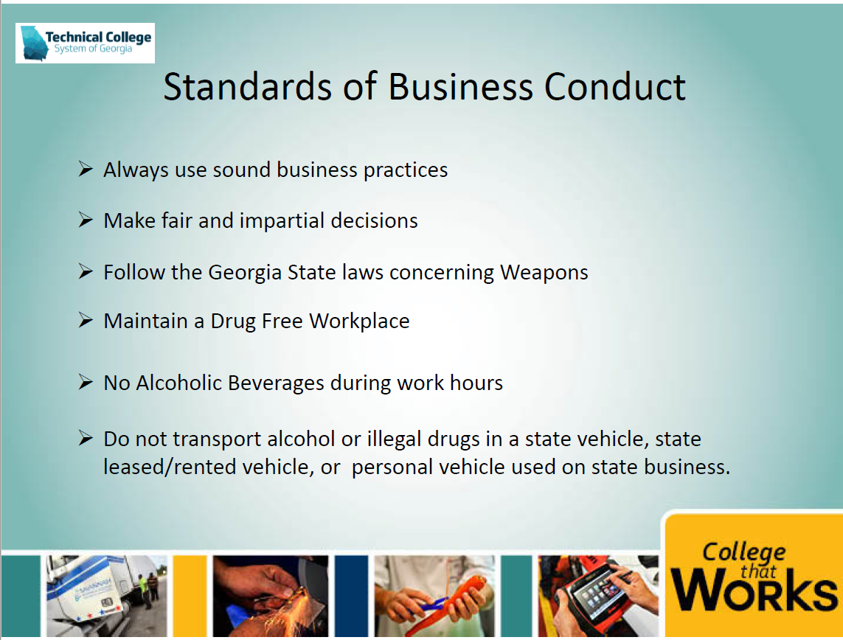

Student Brochures & Pamphlets



